**CS5543 Real-Time Big Data Analytics**

**LAB ASSIGNMENT #2**

**Lab Submission through the following link before 9/7 (W) 11:59PM.**

**https://goo.gl/forms/HGJ0VR8U2dH1K9Yv1**

1. **Spark Programming:**

**Write a spark program with an interesting use case using text data as the input and program should have at least Two Spark Transformations and Two Spark Actions.**

**Present your use case in map reduce paradigm as shown below (for word count).**

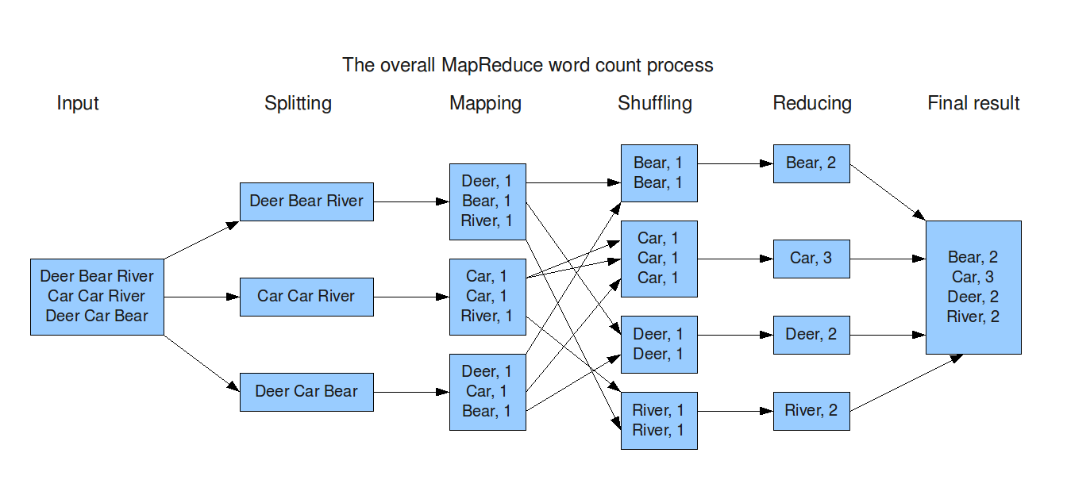

**Submit your Github project for Lab Assignments with source code, input and output data and wiki page containing the report for your lab Assignment including map reduce diagram.**